Jumbo the Elephant  Elephants eat for about 16 hours a day and they consume 150kg of grasses, small plants, bushes, fruit, twigs, tree bark, and roots. In order to find enough food they often have to travel long distances.    - In 5 days Jumbo the elephant walked a total of 80km.  - Each day he walked 4km less than the day before.  - How many kilometres did he walk each day? | Bushbaby diet  Bushbabies are small nocturnal primates. They eat fruits, eggs, seeds, insects and small birds.  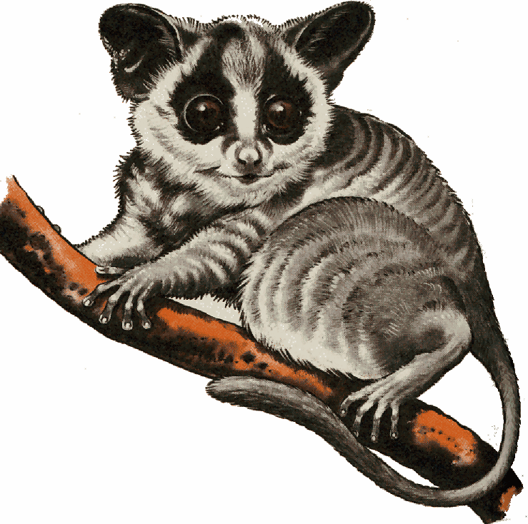  - In 6 days Bertie the bushbaby eats a total of 75 insects.  - Each day it eats 3 fewer insects than the previous day.  - How many insects did it eat each day?
  Day 1 | Day 2 | Day 3 | Day 4 | Day 5 | Total
  Day 1 | Day 2 | Day 3 | Day 4 | Day 5 | Day 6 | Total

Aardvarks and termites  Aardvarks are nocturnal and eat termites. They move from one termite mound to another, dismantling the hills with their powerful claws. Insects are trapped by the aardvark's long tongue, which is covered with thick, sticky saliva.  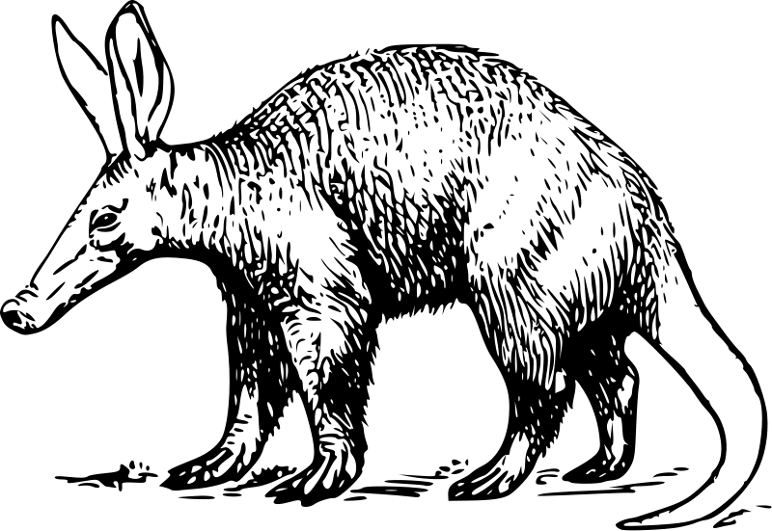  - In 5 hours one night Audra the aardvark raided a total of 110 termite mounds.  - Each hour she raided 5 more termite mounds than the previous hour.  - How many termite mounds did she raid each hour? | Bonobo diet  The bonobo primarily eats fruit, but will also consume shoots, leaves, flowers, seeds, bark, invertebrates, and small vertebrates.  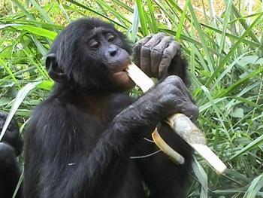  - In 6 days Becky the bonobo eats a total of 102 pieces of fruit.  - Each day she eats 4 fewer pieces of fruit than the previous day.  - How many pieces of fruit did she eat each day?
  Hour 1 | Hour 2 | Hour 3 | Hour 4 | Hour 5 | Total
  Day 1 | Day 2 | Day 3 | Day 4 | Day 5 | Day 6 | Total

Jumbo the Elephant  Elephants eat for about 16 hours a day and they consume 150kg of grasses, small plants, bushes, fruit, twigs, tree bark, and roots. In order to find enough food they often have to travel long distances.  - In 5 days Jumbo the elephant walked a total of 135km.  - Each day he walked 4km less than the day before.  - How many kilometres did he walk each day? | Bushbaby diet  Bushbabies are small nocturnal primates. They eat fruits, eggs, seeds, insects and small birds.  - In 6 days Bertie the bushbaby eats a total of 111 insects.  - Each day it eats 3 fewer insects than the previous day.  - How many insects did it eat each day?
  Day 1 | Day 2 | Day 3 | Day 4 | Day 5 | Total
  Day 1 | Day 2 | Day 3 | Day 4 | Day 5 | Day 6 | Total

Aardvarks and termites  Aardvarks are nocturnal and eat termites. They move from one termite mound to another, dismantling the hills with their powerful claws. Insects are trapped by the aardvark's long tongue, which is covered with thick, sticky saliva.  - In 5 hours one night Audra the aardvark raided a total of 300 termite mounds.  - Each hour she raided 5 more termite mounds than the previous hour.  - How many termite mounds did she raid each hour? | Bonobo diet  The bonobo primarily eats fruit, but will also consume shoots, leaves, flowers, seeds, bark, invertebrates, and small vertebrates.  - In 6 days Becky the bonobo eats a total of 240 pieces of fruit.  - Each day she eats 4 fewer pieces of fruit than the previous day.  - How many pieces of fruit did she eat each day?
  Hour 1 | Hour 2 | Hour 3 | Hour 4 | Hour 5 | Total
  Day 1 | Day 2 | Day 3 | Day 4 | Day 5 | Day 6 | Total

